北京交通大学

《游戏设计与实现》设计文档

学院：软件学院

专业：软件工程

姓名：李奕杭 16126182

岳恬露 16126236

刘小芳16126175

First:Initial envision

General framework：

* Two modes are available for selecting
* Many people can play the game at the same time
* Support team to play the game
* Can turn left or turn right in mode
* Patterns include two scenes: Practice scenes and game scenes

Racing process：

* Show racing car, players have bought or chose the racing car(using gold coins to buy racing car)
* The game start,loading the game scene
* Enter scene,, the track firstly 3D rotation,and then start count down
* Operation process
* After the games finished,and show the ranking list
* In the end pops up the settlement panel

Mode operation：

* Move forward, turn back, turn left and right, Shift key drift, hold down Ctrl key to release energy and accelerate to drive
* Timing is used throughout

Energy tank：

* In the Sonic mode,player can accumulate energy by drift; the energy tank stores 100 energy for the full energy state; when the energy tank is full energy state, the energy will be not accumulated; drifts at the acceleration state, the energy does not accumulate

Accelerate operation：

* Acceleration: Hold down the Ctrl key,it will become accelerated state (energy tank must have energy)

Lens：

* The len always focus on yourself

Ranking rules：

* The shorter the time, the higher the rankings

Determine the outcome：

* The length of time to reach the end point is the benchmark. The shortest time will be the championship; the same time, the same reward; the victory with gold coins reward

Scene display：

* A small map shows the current track section area in the upper right corner of the screen
* The car is shown in the small map

Second: Design ideas   
Preliminary design ideas: ideas design Figure 1-1

1. Mode. The model is divided into practice mode and game mode

2. Vehicles model selecting. There is a default one, and you can buy other vehicles.

3. Track selecting. Tentatively scheduled for 3 tracks.

4. Results determination.In practice mode, there is no score, only the reward, which is set according to the length of time. In game mode, there are scores and rewards, and the winner can get the double reward .

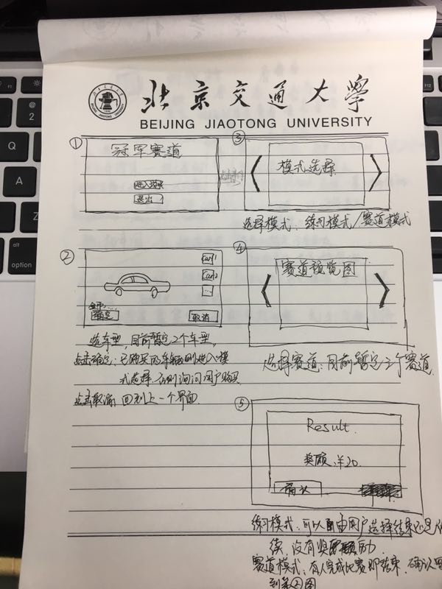

Figure 1-1

Third: the detailed ideas and processes:

1. Enter the start page: you can click the horn to adjust the volume; click into the game button to enter the game interface; click the Exit button.

2. Enter the selected page: you can choose the purchased vehicles, or use gold coins to buy new vehicle. After purchased,you can use new car for the game; click the confirmation button into the game mode and select page; click the cancel button backing to the start page.

3. Enter the game mode selection page: you can click the left and right arrow keys to select a different mode (practice mode and game mode); click to enter the game of loading page; click to cancel backing to the selection page

4. Game loading page: load the game scene and the required game resources, when loading progress bar date reached 100%,enter into the game interface.

5. Game interface in the game mode: first preview the track, and start the countdown; followed by the game, the player complete the game through controlling the vehicle; At the end of the game, display the prompt board; in the game process, click on the house icon button, you can choose to return to the game and continue

unfinished game,or choose to withdraw from the game then back to the selection page, you can adjust the volume; you can get gold coins when the game win,but no reward when the game failed; Then you can choose to exit current game and backing to the election page or select to re-play according to the last game selected vehicles.

1. Game interface in the practice mode: first preview the track, and start to count down; second start the game,and player complete the game through controlling the vehicle.In this mode,the game end until players finish the game.During the game process, click on the house icon button, you can select return to the game, continuing unfinished game, or choose to exit the game backing to the selection page; you can adjust the volume.

Detailed ideas and detailed flow chart Figure 1-2

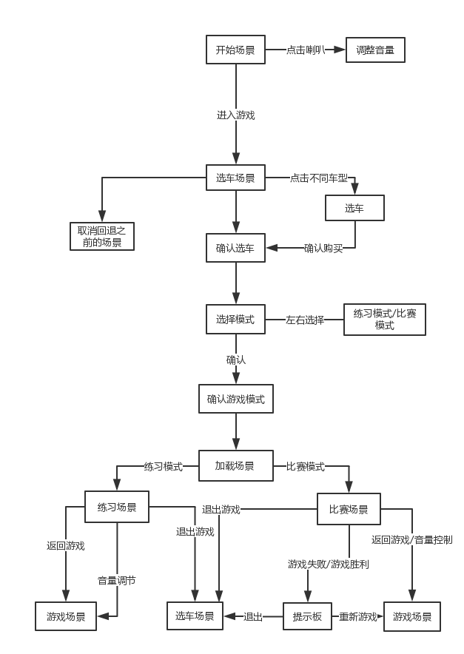

Figure 1-2

Fourth： The main function and implementation methods

Use case diagram 1-3：

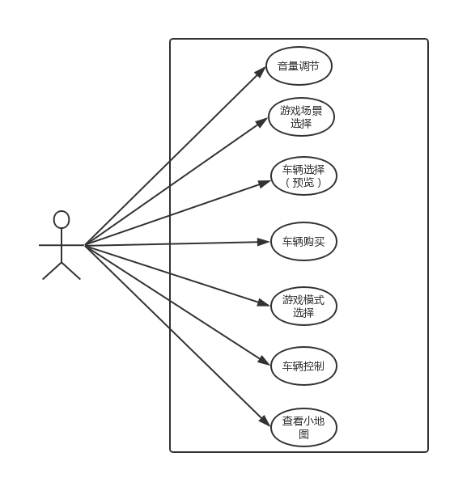

Figure 1-3 use case diagram

The main functions included in the following:

1.Adjustment of background music volume

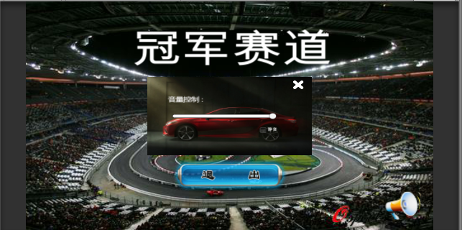

Swipe the slider to adjust the volume level

2. Vehicle selected: there are 3 vehicles; the user can choose any model

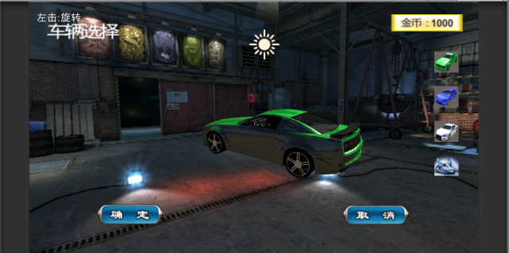

Click on the vehicle on the right to preview the selected vehicle in the middle of the screen.

3. Vehicle purchase: the system default number of gold coins is 1000. Get the gold coins by winning in the game mode

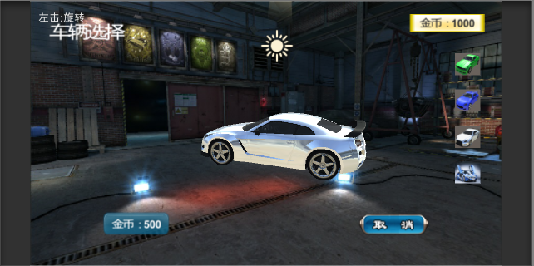  
 Click on the vehicle needed to buy; the lower left corner shows the purchase of gold required; the upper right corner shows currently gold coins the player own

Click onbutton，confirm purchase, the player has a reduced number of gold coins。

4.Game mode select:divided into practice mode and game mode

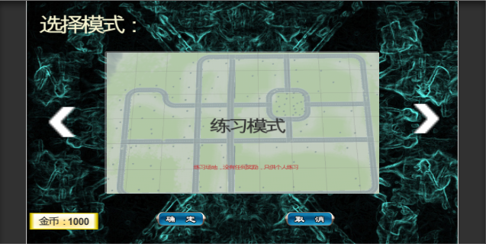

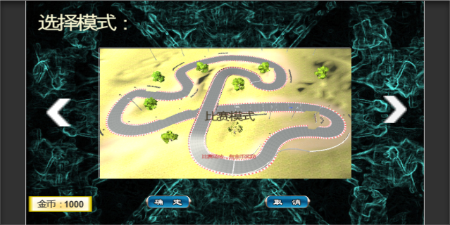

The buttons left or right switch the game mode and the corresponding map.

5. Vehicle control: the vehicle in the course of the game can be forward, back, or turn left, turn right, accelerate

6. Small map display: You can view the route through a small map during a race

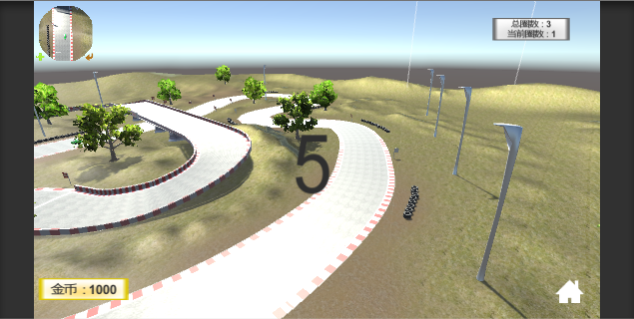

The upper left corner shows the player holding the vehicle is above a certain field of vision.

Fifth: The problems and solutions

1. volume control

Reason: At first, we only think to add background music in the game, did not take the control the size of the volume into account.

Solution: Add a scroll bar, and through the value of the scroll bar to assign the value of the music to the sound size and storage, easily to pass to the next scene.

2.The acceleration is too large when speed up the car .

Reason: In order to make the effect obvious during the development process, the value of the acceleration is set too large.

Solution: Properly adjust the value of the acceleration.

3. The boundary of the scene is unreasonable

Reason: This is a loophole in the design. The problem was found in the development process.

Solution: Set the virtual boundary, and let the car automatically back to the starting point when the car beyond this border. In the process of the game, please determine the position of the car,otherwise it will be reset the car to the initial position if beyond the border.In order to facilitate the decision, the border is set to be a square, only need a parameter to judge.

4. Some models do not deal with collisions

Reason: In the process of making the game scene,it cannot be completed once time; some models dont not set the collision properties .

Solution: Detecting the collision properties of the model in the track and the track around, and then add the collision properties on those did not have. Other models did not do the test. The car also add the collider component.

Six: Test

Have the test according to the following process.

